Assessing the Federal Reserve’s Mandate Fulfillment: Inflation and Unemployment
Shaya Engelman
Story 2 for Data 608
Objective
The Federal Reserve is tasked with a dual mandate from Congress:
- Control Inflation - Achieved through raising or lowering the federal funds rate.
- Maintain Low Unemployment - Ensuring that unemployment levels stay within a reasonable range.
However, these two goals can seem contradictory, as raising interest rates to curb inflation can also lead to increased unemployment. This report explores data from the past 25 years to assess whether the Federal Reserve has successfully balanced these objectives.
We will use the following data:
- Consumer Price Index (CPI) from the Bureau of Labor Statistics (BLS), which measures inflation.
- Federal Funds Rate from the Federal Reserve Economic Data (FRED) API.
- Unemployment Rate from the Bureau of Labor Statistics (BLS).
Data Sourcing
We will pull data from the last 25 years using the BLS and FRED APIs, then plot the results to visualize trends in inflation (CPI), the federal funds rate, and unemployment over time.

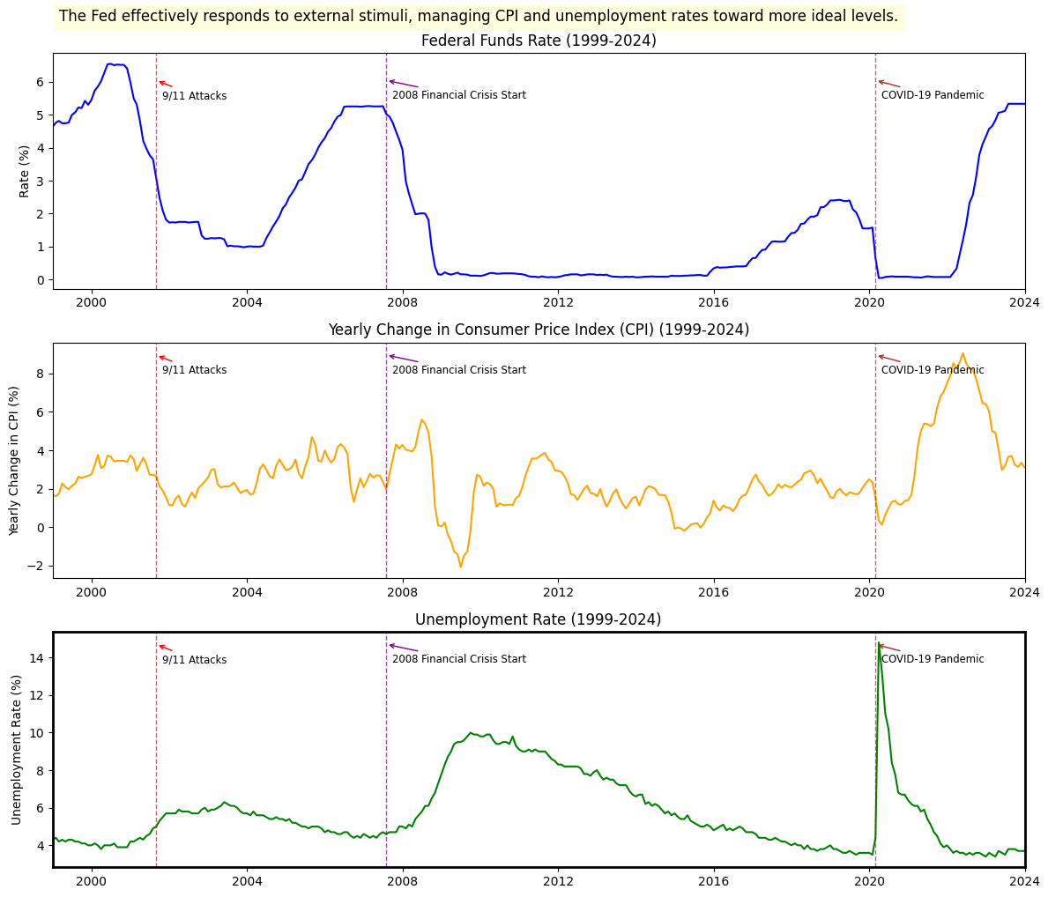
The Federal Reserve typically raises interest rates (Federal Funds Rate) in response to rising inflation (as measured by the CPI). In periods where inflation rises sharply, the Federal Reserve tends to increase the rate to cool off the economy and prevent inflation from spiraling out of control. We can observe this pattern during specific periods, particularly in the early 2000s and around 2022.
Raising interest rates can have a dampening effect on employment. When interest rates rise, it becomes more expensive for businesses to borrow, invest, and hire. As a result, unemployment may rise following rate hikes. We see this during recessionary periods like 2008-2009, where the unemployment rate spiked sharply following rate adjustments.
From this data, we can observe that:
- The Federal Reserve tends to increase interest rates in response to rising inflation, which suggests they are actively trying to control inflation.
- However, periods of high interest rates (intended to curb inflation) often correspond with rising unemployment, highlighting the inherent conflict between these two objectives.
- As a whole though, we can see that the large changes in inflation or unemployment are almost always caused by outside stimuli that aren’t in the Federal Reserve’s ability to stop. The Federal Reserve does seem to do a good job in bringing those factors back to more ideal rates.
In conclusion, while the Federal Reserve has been able to control inflation during certain periods, this has often come at the cost of rising unemployment, making it difficult to perfectly balance its dual mandate. The challenge of managing these contradictory objectives is clearly evident in the data. In the long run, the Federal Reserve does seem to understand these conflicting objectives and ensures no major fluctuations in either to the best of its ability.

